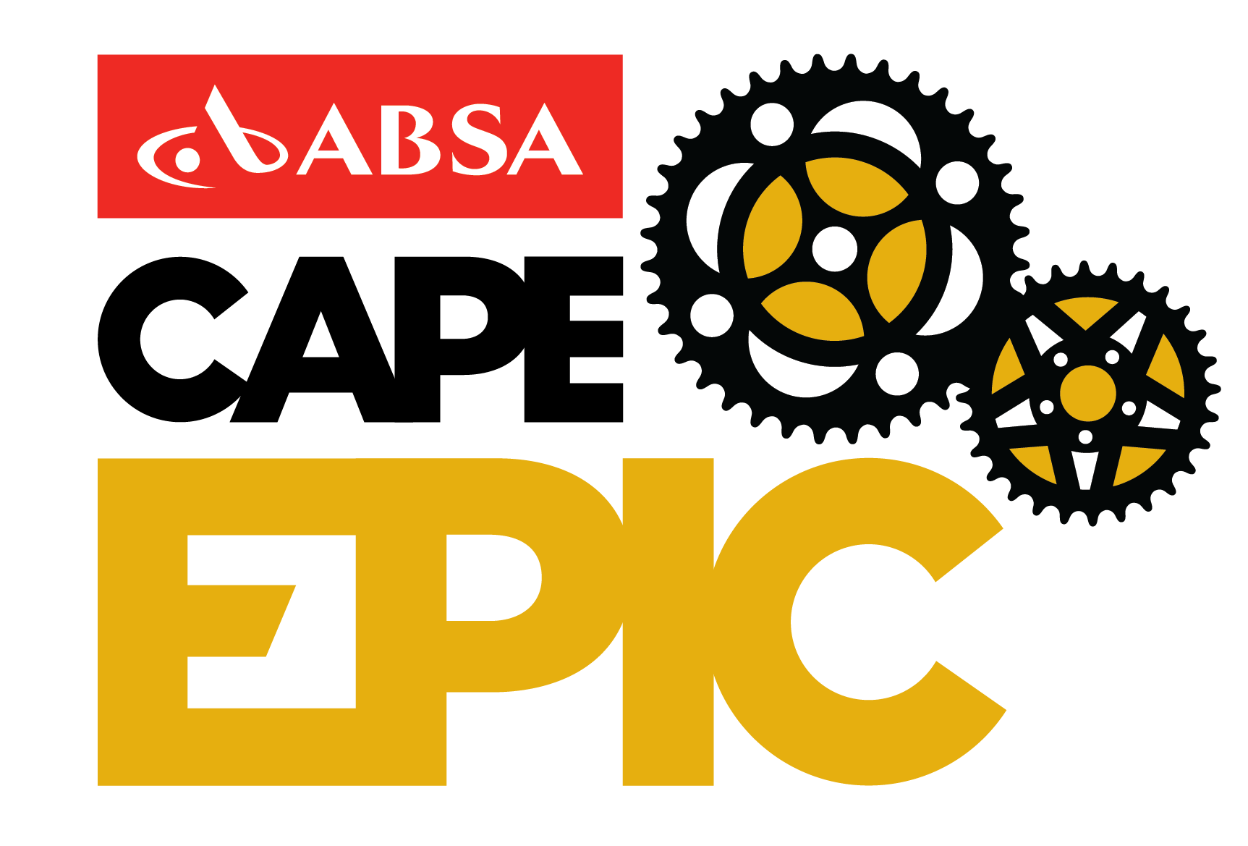

Checklist for the 2017 Absa Cape Epic
- Have you read the race rules?
  - All of the race rules are important.
- When are you arriving in Cape Town?
  - You must be in time for registration on Saturday 18 March 2017 (9am to 2pm).
- Where are you staying until the Prologue?
  - Race accommodation is only provided from the Sunday night after the Prologue or you can purchase a pre-accommodation package through our online store.
- Are your details all correct online? Are you registered in the correct category?
- Have you completed all of your compulsory actions? (these will be made live on your profile later in the year)
- Online medical questionnaire
  - Medical Form signed by a doctor and submitted
  - Liability Form signed by you and submitted
  - Tracking device deposit paid (1 per team)
  - Timing Transponder paid (1 per rider)
  - Submitted your CSA membership number.
- Have you completed your optional actions?
  - Let us know if you are raising money through a charity by completing “My charity” details.
  - Complete the Pre-event Survey to assist us in continuous improvements to the rider experience.
  - Fill in your Rider Bio for our announcers and to tell us your specific story.
- Have you ordered any optional extras such as premium upgrade, massage packages, personal race nutrition?
  - Limited numbers of these are available.
There will be stations set up at registration for you to collect items associated to these packages.
  - Remember to submit your massage booking form, the best time slots fill up quickly.
- Do you know your rider number? (available from mid-February)
- Do you know your Prologue start time? (available from beginning of March)
- Have you deactivated Strava and GPS tracking on all of your devices? As per rule 14.1 in the race rules, no rider may track the route via the use of GPS units or by any other means.
- How are you getting to the Prologue venue?
- How are you getting from the Prologue to the first race village?
  - You can purchase a Coach Transfer, through our online store, and we will transport you, your bike and your bag. If you have purchased a premium upgrade or pre-accommodation package, the coach transfer is already included.
- Plan your race, race your plan and know what your alternatives are should things not go according to plan.
- Where are you staying after the race and how are you getting there?
  - We do have post-accommodation packages available. Purchase through our online store.

How will registration work?
- Arrive at the V&A Waterfront with proof of your ID and CSA membership and your partner.
- Proceed to The Lookout Venue, registration is inside.
- Head to the counter relevant to your rider number, where a friendly volunteer will hand you your race pack and explain all of the items inside as well as assist you with putting on your wristband accreditation.
- Collect optional extras (eg. personal race nutrition, premium upgrade, massage package) from the relevant counters at registration. Please note some of these might be outside the venue.
- Enjoy the sponsor expo as you make your way to collect your rider bag in the designated area (Should you have any questions regarding the contents, please visit race office at the first race village).
- Drop off any bike boxes/bags at the Grand Finale rider bag truck. Items left here will be securely stored offsite during the event and available for collection only at the Grand Finale.
- Attend the rider briefing at the V&A Waterfront amphitheatre at 11am.
- Enjoy the afternoon taking care of last minute preparations and getting some rest.

Some hints of what to pack
- Combination padlock x 2 (one for your tent and one for your rider bag)
- Cable ties
- Wet wipes
- Ear plugs
- Head lamp/torch with extra batteries
- Ziploc bags
- Sleeping bag and liner/sheet
- Pillow
- Quick dry towel
- Sunscreen
- After sun

Stay connected
Twitter: @CapeEpic
Facebook: Cape Epic
Youtube: CapeEpic
Instagram: @capeepic
Website: www.cape-epic.com

Any questions? Email our friendly rider team on: registration@cape-epic.com

We are here to help and support you throughout your Absa Cape Epic journey!

